Convert ER to relational model

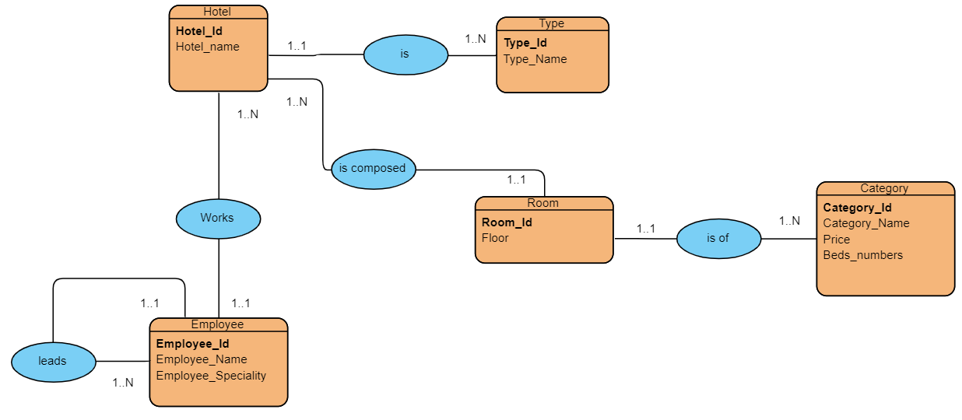

Hotel (**hotel_id** ,hotel_name)

Type(**type_id**, type_name , **#hotel_id**)

Room(**room_id** , type_name, **#hotel_id**)

Category(**category_id** , category_name,price,beds_numbers,**#room_id**)

Employee(**employee_id**,employee_name,employee_speciality**,#hotel_id**)

Employee(**employee_id**,employee_name,employee_speciality**,#director_id**)